**What is DevOps?**

**DevOps** (combination of "software **DEV**elopment" and "information technology **OP**eration**S**") is a term used to refer to a set of practices that emphasize the collaboration and communication of both software developers and information technology (IT) professionals while automating the process of software delivery and infrastructure changes. It aims at establishing a culture and environment where building, testing, and releasing software can happen rapidly, frequently, and more reliably.

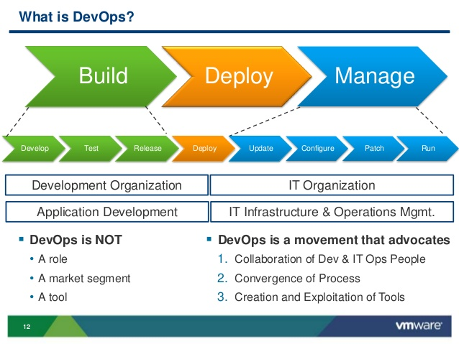

DevOps is a cultural shift and collaboration (between development, operations and testing), there is no single "DevOps tool": it is rather a set, consisting of multiple tools.[[](https://en.wikipedia.org/wiki/DevOps#cite_note-12) Generally, DevOps tools fit into one or more of these categories, which is reflective of key aspects of the software development and delivery process:

1. Code — Code development and review, version control tools, code merging;
2. Build — Continuous integration tools, build status;
3. Test — Test and results determine performance;
4. Package — Artifact repository, application pre-deployment staging;
5. Release — Change management, release approvals, release automation;
6. Configure — Infrastructure configuration and management, Infrastructure as Code tools;
7. Monitor — Applications performance monitoring, end–user experience.

Though there are many tools available, certain categories of them are essential in the DevOpstoolchain setup for use in an organization.

Tools such as [Docker](https://en.wikipedia.org/wiki/Docker_%28software%29) (containerization), Jenkins (continuous integration), Puppet (Infrastructure as Code) among many others—are often used and frequently referenced in DevOps tooling discussions

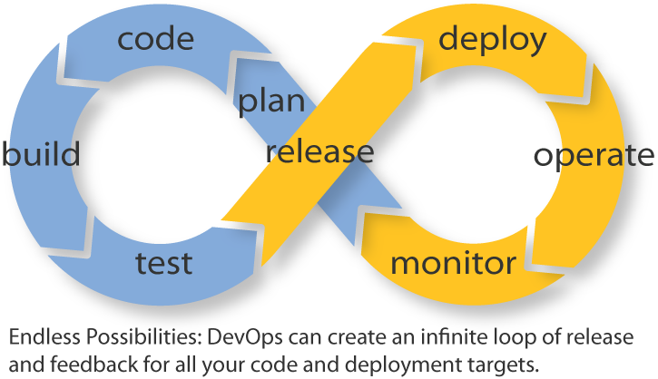

### Benefits of DevOps

Companies that practice DevOps have reported significant benefits, including: significantly shorter time to market, improved customer satisfaction, better product quality, more reliable releases, improved productivity and efficiency, and the increased ability to build the right product by fast experimentation.

However, a study released in January 2017 by F5 of almost 2,200 IT executives and industry professionals found that only one in five surveyed think DevOps had a strategic impact on their organization despite rise in usage. The same study found that only 17% identified DevOps as key, well below software as a service (42%), big data (41%) and public cloud infrastructure as a service (39%).